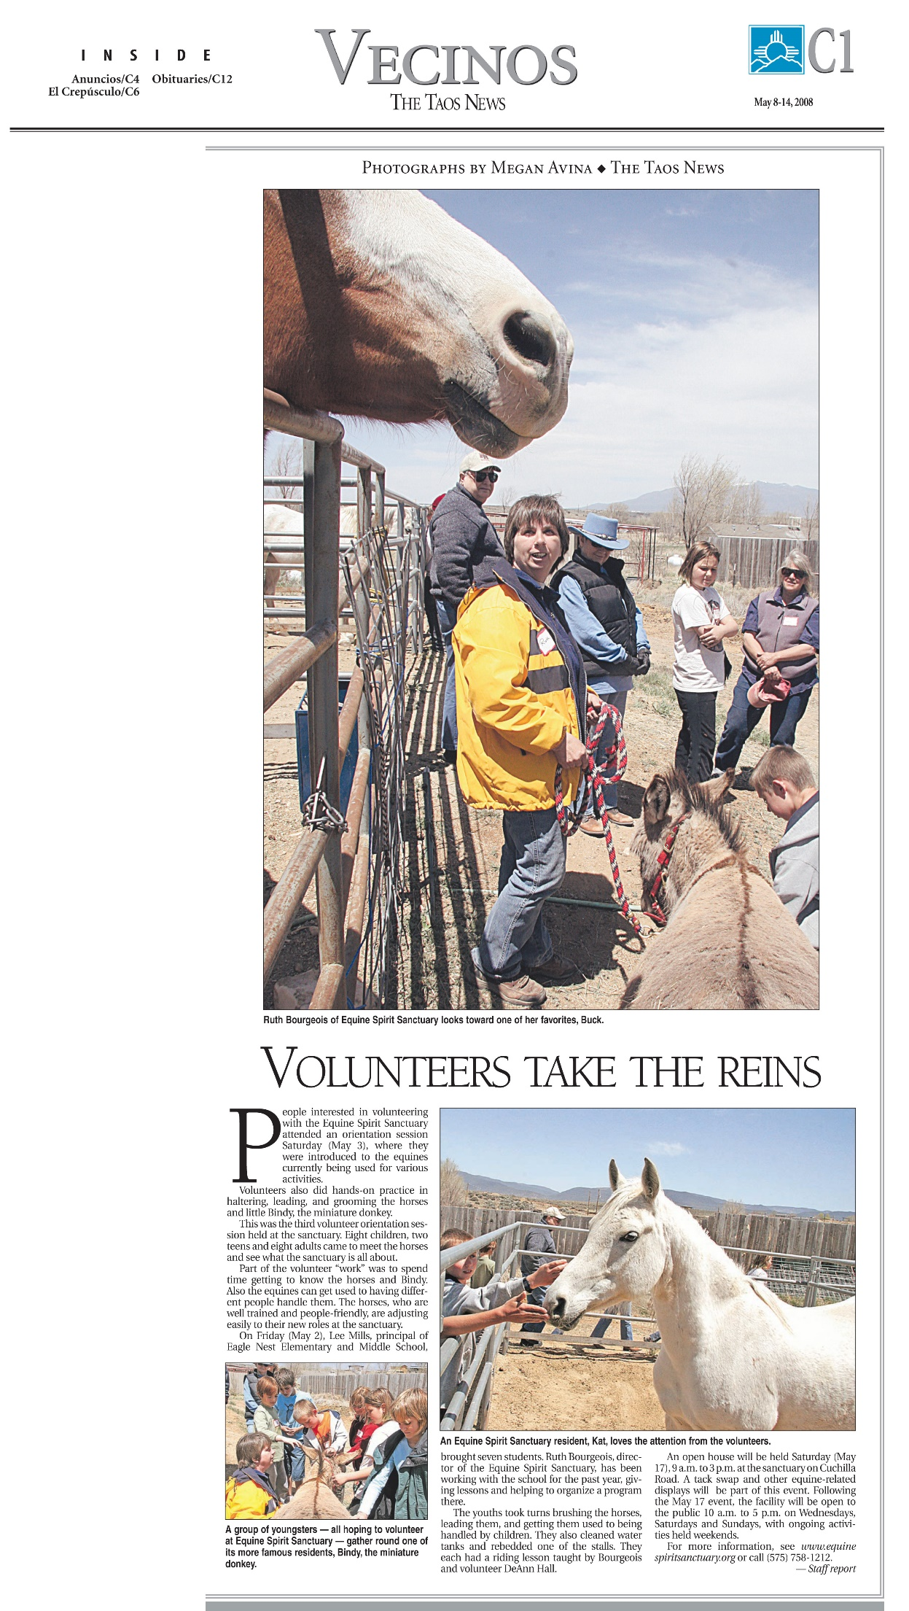*The Taos News*, May 8, 2008